# **How to move or relocate /var folder to a new partition in Linux**

### Situation

How to move or relocate /var folder to a new partition in Linux

### Resolution

Sometimes it may be necessary to move linux directories to separate partitions because the root partition is too small and cannot be resized or extended.  
  
To relocate or move the /var folder to a new partition in Linux, please follow the steps below:

1. Add a new hard disk to the server.  
   *Note: If this is a virtual machine, see how to add a new virtual hard disk to the VM with a corresponding vendor.*
2. Mount the new filesystem in /mnt, from ***fdisk***:

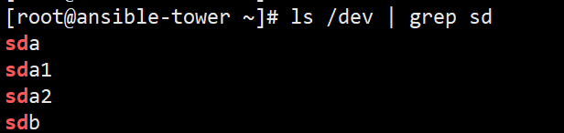

* + Launch fdisk, select Partitioner | expand Hard Disks | select Add Partition...
  + 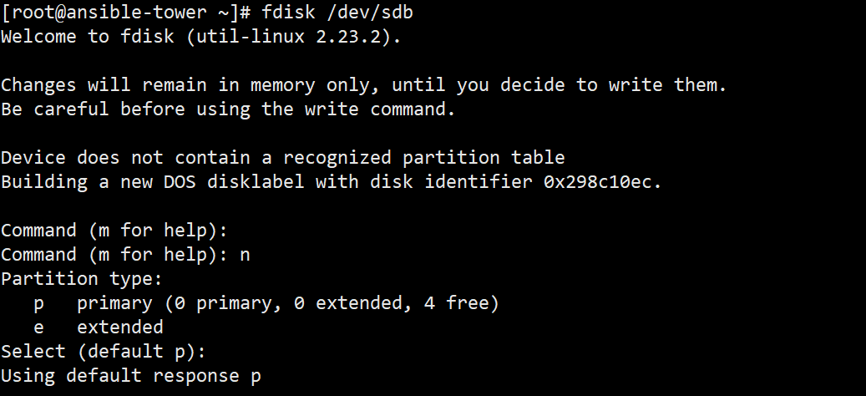

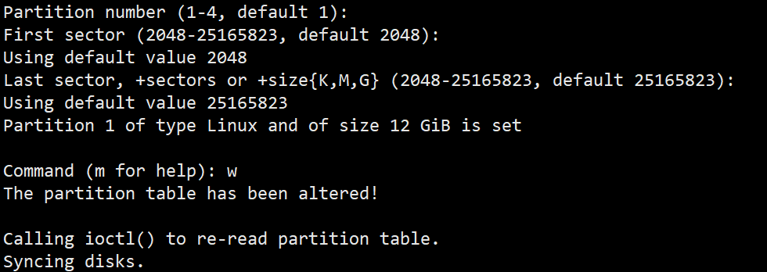

* + - New Partition Type: Primary Partition
    - Select Maximum Size, if preferred.
    - Formatting Options: ext4 (default)

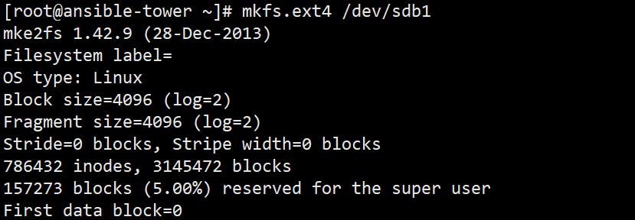

* + - Mounting Options: Mount Partition and specify Mount Point as /mnt/newvar  
      *Note: If there is a problem, the directory may need to be created first.*

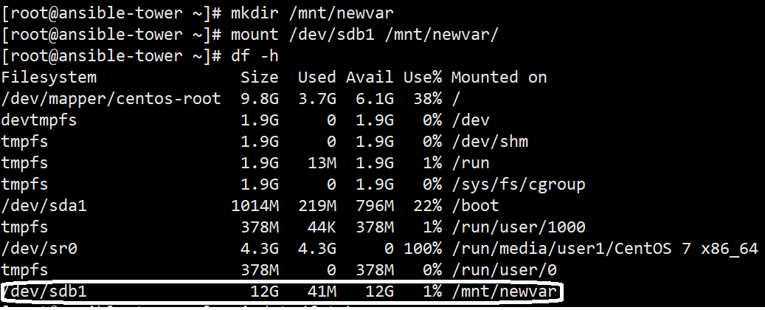

Now, lets make this mount as permanent by adding an entry in the “/etc/fstab”

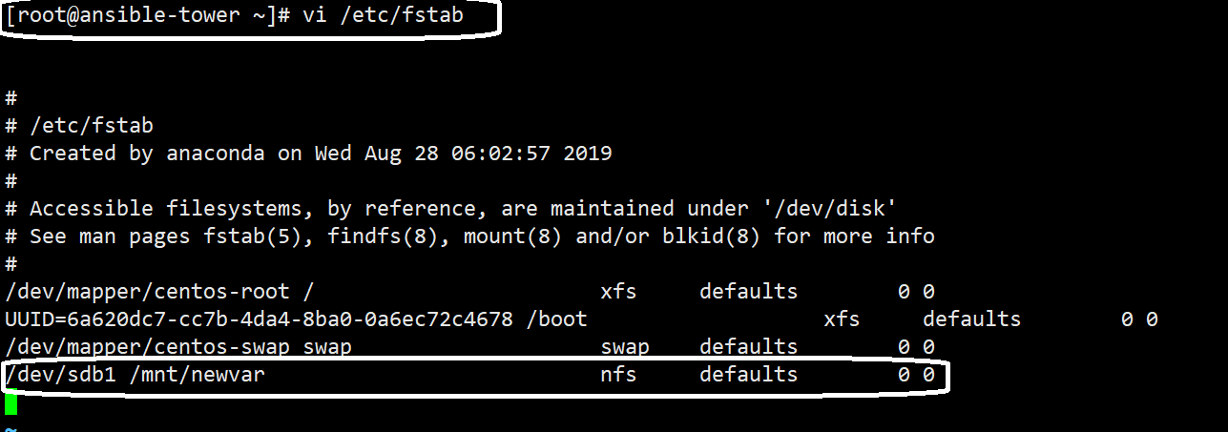

1. Switch to single-user mode:  
   init 1  
   *Note: This will reboot the server into single-user mode where services aren't started and networking is offline for the server. Please login as root when the login dialog is presented and proceed to open a terminal window.*

Note: -- only via the console access you can login to the machine

Input the pwd for the root and login.

1. Copy the data in var only to the new mounted filesystem:  
   cp -apx /var/* /mnt/newvar
2. Rename the current /var directory for backup purposes:  
   mv /var /var.old
3. Make the new var directory:  
   mkdir /var
4. Edit the /etc/fstab file:
   * Replace /mnt/newvar with /var
   * Save and Close the file.

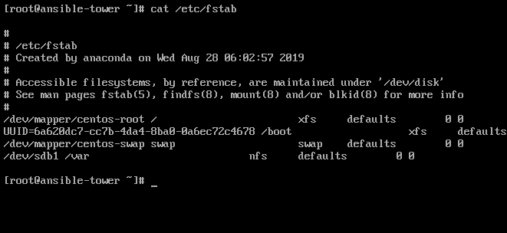  
*Note: The new partition is now configured to be mounted at /var on boot.*

1. Restart the server.